**Program-1: Write a JavaScript that calculates the squares and cubes of  the numbers from 0 to 10 and outputs HTML text that displays the  resulting values in an HTML table format.**

**<!DOCTYPE html>**

**<html>**

**<head>**

**<title>Squares and Cubes</title>**

**<style>**

**table,tr, td**

**{**

**border: solid black;**

**width: 25%;**

**text-align: center;**

**border-collapse: collapse;**

**background-color:rgb(191, 255, 0);**

**}**

**table { margin: auto; }**

**.blink {**

**animation: blink 3s infinite;**

**}**

**@keyframes blink {**

**0% {**

**opacity:2;**

**}**

**100% {**

**opacity: 0;**

**font-size: 20px;**

**font-weight: bold;**

**color:blue;**

**}**

**}**

**</style>**

**</head>**

**<body>**

**<table border="1" align="center">**

**<tr>**

**<th colspan="3"> NUMBERS FROM 0 TO 10 WITH**

**THEIR SQUARES AND CUBES  </th>**

**</tr>**

**<tr>**

**<td> NUMBER </td>**

**<td> SQUARE </td>**

**<td> CUBES </td>**

**</tr>**

**<script type="text/javascript">**

**for(var i=0;i<=10;i++)**

**{**

**document.write("<tr align='center'><td>" + i + "</td><td>" + i*i**

**+"</td><td>" + i*i*i + "</td></tr>")**

**}**

**</script>**

**</table>**

**<p class="blink" align="center"> "Assigment-2 Challenge Completed" </p>**

**</body>**

**</html>**

**Output:**

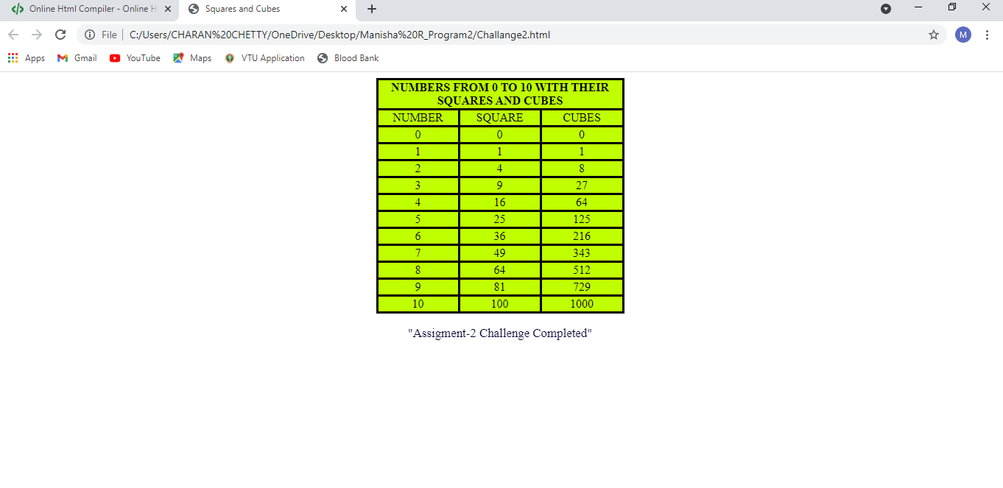

**Test Cases for challenge:**

|  |  |  |
| --- | --- | --- |
| Test | No. Input Parameters | Output image |

|  |  |  |
| --- | --- | --- |
| 1 | i=0 to 10,  increment of i+1 |  |

|  |  |  |
| --- | --- | --- |
| 2 | i=10 to 100,  increment of i+10 |  |
| 3 | i=100 to 1000,  increment of i+100 |  |